Seneca Gaming Corporation


Seneca Niagara Resort & Casino
OS&E Niagara Guest Room Renovation
RFP SNRC-0030-26SDH

Confidential

January 21, 2026

Table of Contents
I. Introduction 2
II. RFP Objective 2
III. Product Specifications 2
A. Coffee Maker and Coffee Amenity Tray: 2
B. Ice Bucket Tray 3
C. Ice Bucket 3
D. Bathroom Soap Dish 3
E. Bathroom Tissue Holder 4
F. Bathroom Wastebasket & Plastic Liner 4
G. Waste basket in Room: 5
H. Men’s Hangers 5
I. Women’s Hangers 5
J. Iron & Ironing Board Mount 6
IV. Project Timeline 6
V. RFP Administrative Information 7
A. Contact Information 7
B. Schedule of Events 7
C. Bidder Questions 7
D. Submission of Proposals 7
E. Proposal Format 7
F. Conditions 9
G. Proposal Evaluation/Vendor Selection 9
H. General Bidder Information 10
I. SGC Standard Terms and Conditions 10
J. Tax Exempt Status 10
K. Payment Terms 10
VI. Supplemental Bidder Information 11
A. Business Continuity 11
B. Conformity of Proposal with SGC Requirements 11
C. Seneca Nation Business Registration Fee (SNIBRF) 11
VII. Bidder Certifications and Representations 12

Introduction
Seneca Gaming Corporation is a wholly owned, tribally chartered corporation of the Seneca Nation of Indians (the “Nation”) which operates all of the Nation’s Class III gaming operations in Western New York. Seneca Gaming Corporation, through its wholly owned subsidiaries, owns and operates Seneca Niagara Resort & Casino in Niagara Falls, New York, Seneca Allegany Resort & Casino in Salamanca, New York, and Seneca Buffalo Creek Casino in Buffalo, New York.
For additional information, please visit our website at www.Senecacasinos.com.

RFP Objective
Seneca Gaming Corporation (hereinafter referred to as SGC) is seeking qualified Operating Supplies & equipment (OS&E) manufacturers and suppliers to prepare and submit proposals based on the attached updated Specifications and Quantities (listed in attached Exhibit A) to support the Guest Room Renovation Project at its Seneca Niagara Resorts & Casino location in Niagara Falls, NY.
The scope of this RFP is specific to OS&E
SGC’s Architecture of Record for this project is SOSH/WATG.

Product Specifications

Coffee Maker and Coffee Amenity Tray:
Quantity: 624
Material: Leatherette Exterior with Removable PVC lining on interior
Color: Espresso Brown Leatherette with Black interior Liner
Dimensions: As required to fit the following items:
  - Keurig Coffee Maker
  - 4 or 6 Keurig cups?
  - 2 coffee condiment kits – 2 sugar packets, 1 powder creamer, 1 sugar substitute, 1 stir stick, and 1 napkin. All items in a single plastic wrapping.
  - 2 ceramic mugs
  - 2 disposable paper cups
  - Four bags of tea.
Basis of Design Product: Monastery Hill Custom Wide Tray Keurig Organizer https://monasteryhill.com/hotel-room-products/coffee-organizers/keurig-organizers/
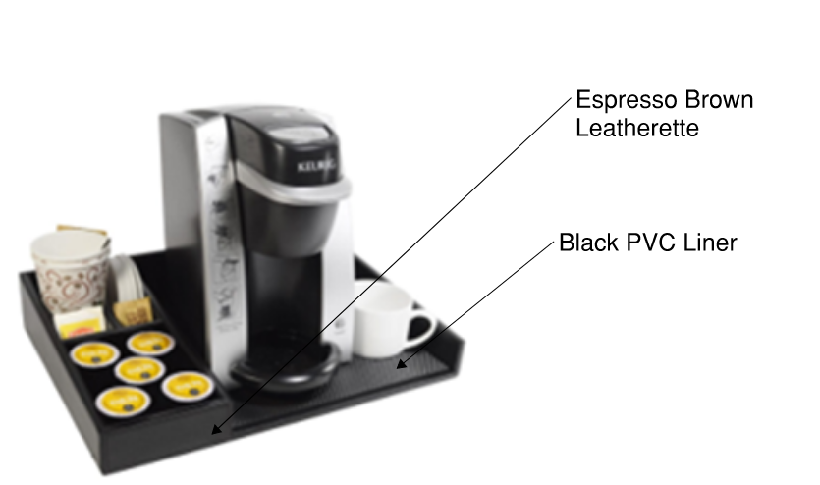

Ice Bucket Tray
Quantity: 624
Material: Leatherette
Color: Espresso Brown Leatherette
Dimensions: 15″Dia x 1″H, CP 6
Capable of fitting the following items:
  - Ice Bucket
  - Two (2) bottles of water (for purchase with paper tag signs around necks of bottles)
  - Two (2) glasses (On top of two paper coasters that are SNC branded)
  - Two (2) plastic cups
Basis of Design Product: https://www.paradigmtrends.com/product/millennium/
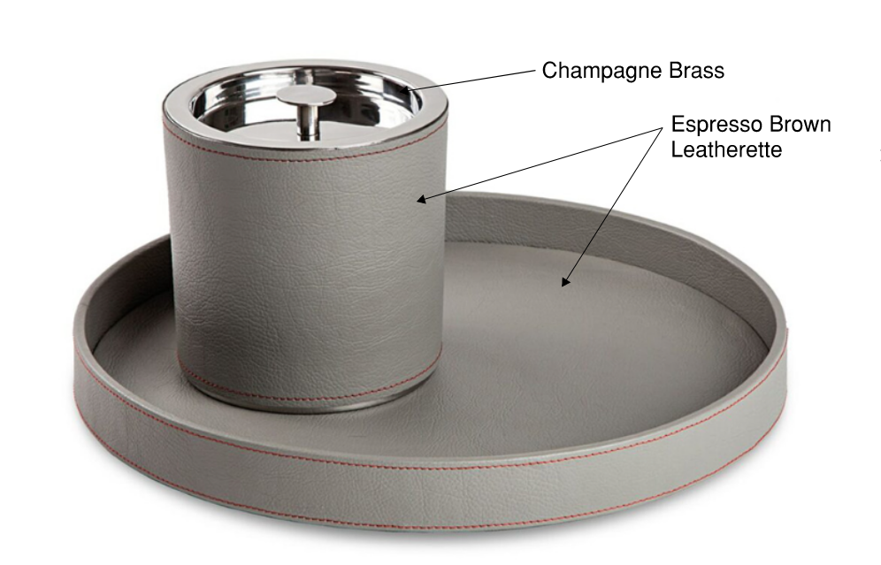

Ice Bucket
Quantity: 624
Material: Leatherette & double lined 18/8 stainless steel
Color: Espresso Brown Leatherette & Champagne Brass Accent Finish
Capacity: 3 Quarts
Basis of Design Product: https://www.paradigmtrends.com/product/millennium/

Bathroom Soap Dish
Quantity: 624
Material: Resin
Color: Glossy White
Dimensions: 5.125″ L x 3.50″ W x 1″ H, CP 24
Basis of Design Product: https://www.paradigmtrends.com/product/delta-white/
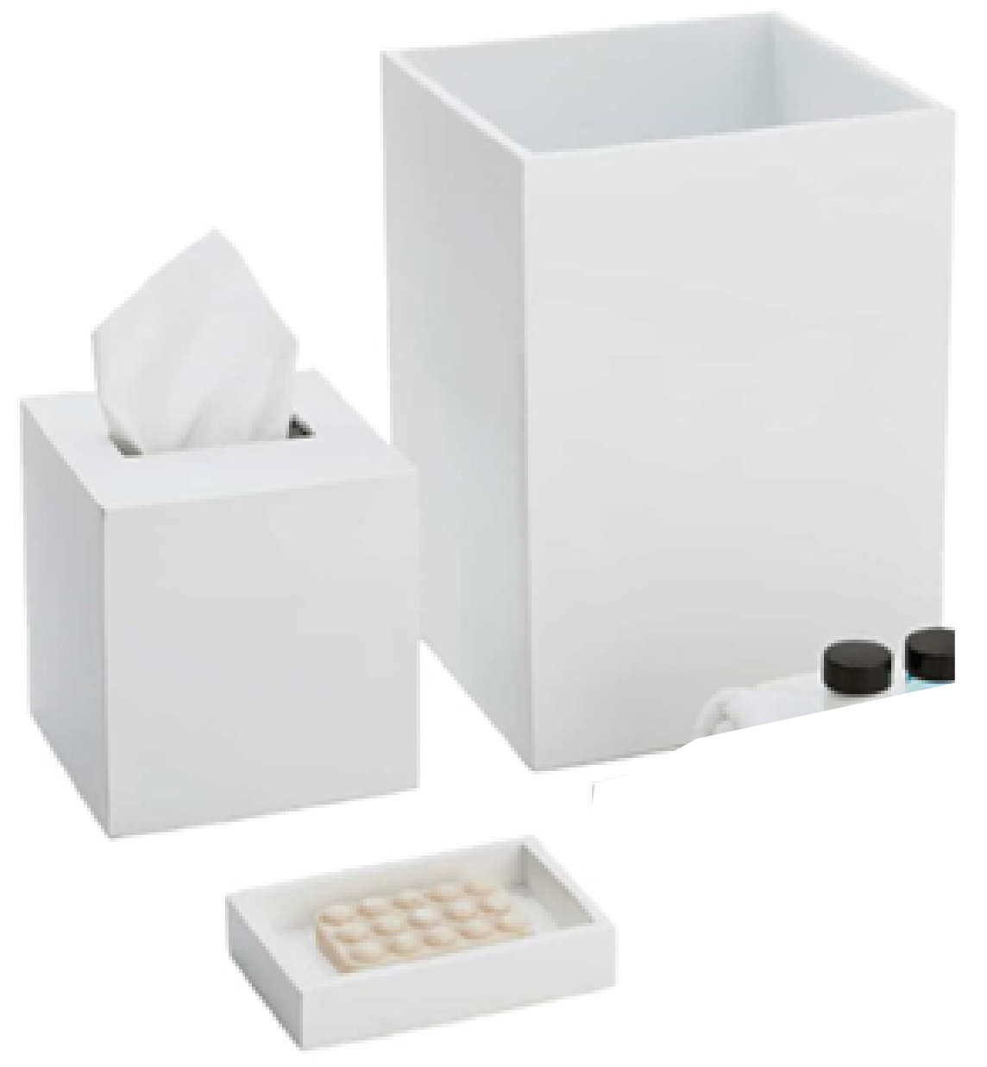

Bathroom Tissue Holder
Quantity: 624
Material: Resin
Color: Glossy White
Dimensions: 7.75″ x 7.75” x 11″H, CP 4
Basis of Design Product: https://www.paradigmtrends.com/product/delta-white/

Bathroom Wastebasket & Plastic Liner
Quantity: 624
Material: Resin Wastebasket with Plastic Liner
Color: Glossy White
Dimensions:
  - Wastebasket - 7.75″ x 7.75” x 11″H
  - Liner: 6.75″ SQ x 6.625″ SQ x 9.75″ H
Basis of Design Product: https://www.paradigmtrends.com/product/delta-white/

Waste basket in Room:
Quantity: 624
Material: Leatherette Wastebasket with Powder Coated Metal Liner
Color: Espresso Brown Leatherette with Black interior Liner
Dimensions: 9.75″Sq x 8.25″Sq x 11″H, CP 4
Basis of Design Product: https://www.paradigmtrends.com/product/berlin/
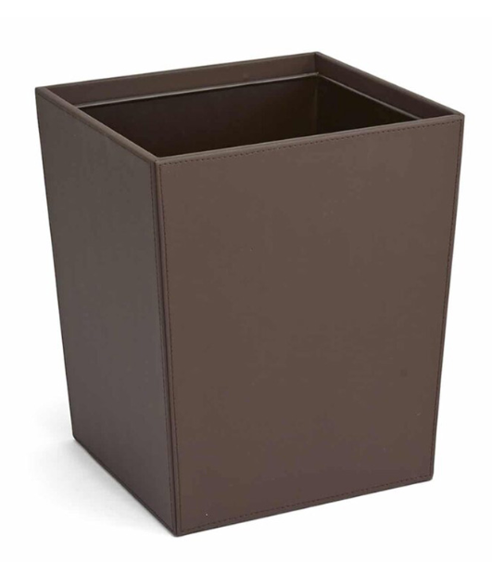

Men’s Hangers
Quantity: 2,436
Description: Men's Hanger, Mini Hook Contour with Locking Bar, Walnut with Brass Hook
Material: Wood & Metal
Color: Dark Walnut
Dimensions: 9.75″Sq x 8.25″Sq x 11″H, CP 4
Basis of Design Product: https://www.guestsupply.com/catalog/Guestroom-Accessories/Hangers-And-Accessories/Hangers/019274-Men-s-Hanger-Mini-Hook-Contour-with-Locking-Bar-Walnut-with-Brass-Hook


Women’s Hangers
Quantity: 2,436
Description: Women's Hanger, Mini Hook Contour w/ Clips, Walnut with Brass Hook & Clips
Material: Wood & Metal
Color: Dark Walnut
Dimensions: 9.75″Sq x 8.25″Sq x 11″H, CP 4
Basis of Design Product: https://www.guestsupply.com/catalog/Guestroom-Accessories/Hangers-And-Accessories/Hangers/019275-Women-s-Hanger-Mini-Hook-Contour-with-Clips-Walnut-with-Brass-Hook-And-Clips


Iron & Ironing Board Mount
Quantity: 624
Description: Mount to hold Iron and Ironing Board. Universal size. Accommodates irons with base profiles of 5” wide x 3.375” deep (or smaller). Mounting hardware shall be included. Durable, heat resistant thermoset plastic allows storage of hot, unplugged irons.
Material: Metal / Thermoset Plastic
Color: Black
Basis of Design Product: https://www.guestsupply.com/catalog/Guestroom-Accessories/Ironing-Boards-Covers-And-Mounts/Ironing-Board-Wall-Mounts-And-Organizers/0076880-Closet-Organizer-Black
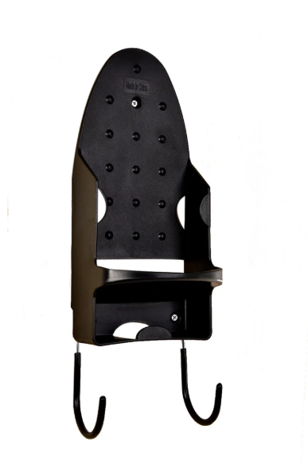

Project Timeline
Submittals and shop drawings are due within two (2) weeks (or less) of PO issuance.
Delivery of mock up room items is due within four (4) weeks (or less) of approved submittals and receipt of mock up room deposit.
Delivery of full production and attic stock quantities is due within ten (10) weeks (or less) of approval of mock up room products and receipt of full production deposit.
Delivery of full production quantities may be accepted on a phased approach in accordance with the below schedule:
- Floors 26 through 21: September 1st, 2026
- Floors 20 through 15: December 1st, 2026
- Floors 14 through 8: March 1st, 2027
- Floors 7 through 4: May 1st, 2027
- Attic Stock: May 1st, 2027

RFP Administrative Information

Contact Information
Please use the following name and email address for all correspondence with SGC concerning this RFP.
Name Shelle Heaton
Telephone 716-345-1594
Email sheaton@senecacasinos.com

Schedule of Events
RFP issue date: 01/21/2026
Bidder questions due: 01/28/2026
Bid Submission Deadline: 02/04/2026

Bidder Questions
Bidders must submit any questions to the Facilitator’s email address directly. No telephone questions will be accepted or considered.
Questions must reference the specific RFP paragraph number and page and quote the passage being questioned. SGC will respond to questions promptly and will send answers to Bidders as a group.

Submission of Proposals
Proposals must be submitted in electronic form, preferably in Microsoft Word and/or Microsoft Excel formats. Note: SGC’s email system rejects incoming messages with attachments exceeding 20 MB. Bidders are encourage to confirm that the Coordinating Buyer received their bid, prior to the bid submission deadline (date and time) indicated in the above schedule of events.
The Coordinating Buyer must receive proposals on or before the bid submission deadline. Proposals received after the bid submission deadline will not be considered.

Proposal Format
Send RFP response with all requested information answered in the format provided, along with any supporting attachments, electronically via email as stated in (above) Section E. Submission of Proposals.
Bidders must complete the attached excel workbook Exhibit A
In addition, the following documents must be sent with your RFP response:
Part-1 Bidder Representations and Certifications
A corporate officer or person who is authorized to represent Bidder must complete, sign and date the Bidder Certifications and Representations, Section VII of the RFP.
Part-2 Appendix
Appendix-A: Evidence of Insurance
Evidence of current insurance is to be provided to the satisfaction of SGC’s Risk Management Department. Insurance requirements vary depending upon the nature of the services and the degree of risk. Standard requirements include minimum $5 million general liability coverage (per occurrence and in the aggregate) [$10 million for construction-related contracts], $1 million automobile liability coverage, combined single limit, for all vehicles brought on-site, worker’s compensation and employer liability insurance in accordance with state law. Additional types of insurance, including, without limitation, professional liability insurance and network privacy/data security/cyber liability insurance, may be required in specific circumstances. SGC and related persons and entities will be additional insured under the general liability and automobile liability policies of insurance.
SGC’s Risk Management Department has discretion to increase, decrease, or dispense with insurance in appropriate cases. They may, in addition to or instead of insurance, require signature of a Waiver, Indemnification and Hold Harmless form by any individuals who will be present on SGC property.
Additional Insured language:
Seneca Gaming Corporation and their parent, Subsidiaries, Directors, Officers, Agents, representatives and Employees are named as Additional Insures on the General Liability and Automobile Liability policies. A waiver of subrogation applies on all policies, including Employer’s Liability, in favor of Seneca Gaming Corporation.
Seneca Gaming Corporation to be named as Certificate Holder:
Seneca Gaming Corporation
310 Fourth Street
Niagara Falls, NY 14303
Certificates evidencing such coverage shall be provided prior to commencement of work and renewal certificates shall be provided upon availability.
SGC’s Risk Management Department has discretion to increase, decrease, or dispense with insurance in appropriate cases. They may, in addition to or instead of insurance, require signature of a Waiver, Indemnification and Hold Harmless form by any individuals who will be present on SGC property.
For additional details, see section 22 of SGC’s Standard Terms & Conditions at https://senecacasinos.com/media/zqdd2j1f/sgc-standard-terms-and-conditions-v-10-30-20.pdf
Appendix-B: Standard Agreements
Bidders are invited to include their standard form of agreement (preferably in Word format) to form the basis of the contract should it be awarded to them. However, SGC reserves the right to utilize its own standard form of agreement.
Part-3 Company Overview
Section 1: Company Overview
Provide a brief description of the overall organization of your company including the location of corporate headquarters, primary industries and markets served, how long the company has been in business and what experience your company has serving multi property and Native American-owned casinos and casino resorts, if any.
Section 2: Executive Summary
The purpose of this section is to summarize your proposal for SGC evaluators and decision makers. The summary should include, at minimum, key proposal elements, your vectors of competitive differentiation and an overview of your pricing model.
Section 3: Bidder Supplemental Information
The purpose of this section is to afford Bidder an opportunity to present necessary information that was not requested. This bidder can also present alternative solutions, as well as any value-add proposals
Section 4: References
Include a minimum of three contracts for goods or services similar to those in the RFP’s Requirement Specifications that were awarded within the last three (3) years, along with contact information for each client reference. Wherever possible, include casino and casino-resort clients in these references.

Conditions
Under no circumstances will responses be made available to other organizations, either wholly or in part, without Vendor’s prior written permission.
By participating in this RFP:
- Bidder agrees that you will not directly contact any SGC employee without prior written approval from SGC. Failure to do so may revoke your invitation to participate in this RFP.
- Bidder agrees to keep confidential all information related to this RFP. Any sharing of this information without express permission will exclude Vendor from consideration. This RFP and all supporting attachments and related communications may not be duplicated or distributed in any form to any other company without prior written permission.
Bidder agrees that all information provided in their RFP response is valid for a minimum of 90 days from the response date.
All costs incurred by the bidder for participating in this evaluation will be the responsibility of the bidder. SGC will not reimburse any bidder costs or expenses.
All responses to the RFP become the property of SGC.

Proposal Evaluation/Vendor Selection
Proposals will be evaluated to determine their completeness and compliance with the mandatory requirements and qualifications specified throughout this document. Failure to comply with one or more of these requirements may result in the proposal being rejected as non-responsive. SGC reserves the right to waive deviations it deems non-material and/or to reject any and all Proposals in its sole discretion.
The successful Bidder(s) will be notified by email of the award of contract, conditional upon appropriate licensure through SGC’s regulatory authority, the Seneca Gaming Authority (“SGA”), providing proof of insurance to the satisfaction of SGC’s Risk Management Department, and signature of a contract and/or issue of a Purchase Order. It is only following all of these actions that the successful Bidder will be considered a Vendor of SGC.
Successful Bidders must complete SGC’s Vendor Registration Form and W-9 (or equivalent for non-U.S. persons/entities). If required, they must also complete and submit to the SGA the requisite vendor license application. They are also responsible for payment of SGA processing or vendor license fees plus the Seneca Nation of Indians Business License fee as detailed in paragraph VI. I. below. Fees range from $750 to $2,500 depending upon the nature of the services. These requirements must be completed and, if applicable, the requisite SGA vendor license issued, prior to signature of the contract. Vendor licenses and fees must be renewed every two years. SGA may also, in an appropriate case, require the licensure of individual employees who perform certain services that are or may be closely associated with SGC’s casino operation. As SGA retains the discretion to make this type of determination on a case-by-case basis, SGC is unable at the RFP point in the bidding process to state definitively whether such licensure will be required in any particular case.

General Bidder Information
This RFP does not commit SGC to award a contract, to pay any costs incurred in the preparation of the RFP, nor to procure or contract for services or supplies.
It is the policy of SGC that all Proposals are to be held unopened and confidential until after the closing date and time. At the bid opening, Proposals will be opened by the contact Coordinating Buyer and are reviewed by a compliance representative.
Bid Validity. Bidder’s bid submission must remain valid for a minimum of ninety (90) days from the bid closing date.
Minority Bidders: SGC gives priority to Bidders who are Native American, minority, women-owned or small disadvantaged businesses. If your company falls into any of these categories or has contracted with such businesses for the purpose of the proposal, please note as such on your proposal.
Alternative Proposals (if applicable) are accepted based on the following conditions: SGC will consider alternative proposals from Bidders provided they have submitted a response based on the original requirements. The alternative Proposal will be submitted separate and apart from the basic Proposal. It is assumed that the materials included in the alternative Proposal meet all of the qualifications of the original Proposal.
Substitutes. Any recommended substitutions should be attached separately. Products may require testing before acceptance. Bidder’s pricing must include the conversion calculations if your size, pack, weight, etc. is not the same as the specified product(s). SGC solicits Bidders’ recommendation(s) for new products and/or services leading to lower costs.
Projected Volume. Bidders are advised that the volumes or quantities indicated on the RFP are for reference purposes only and must not be taken as guaranteed or as constituting representations by SGC. Actual volume and quantities may vary depending upon the needs of the SGC departments or business units for which the goods and/services are destined and fluctuations in the business cycle.

SGC Standard Terms and Conditions
Any purchase order or contract flowing from this RFP (in the absence of language to the contrary in the contract) is subject to the terms and conditions hereof as well as to Seneca Gaming Corporation’s Standard Terms and Conditions which are available on the following website: https://senecacasinos.com/media/zqdd2j1f/sgc-standard-terms-and-conditions-v-10-30-20.pdf.
Reference to, or inclusion of, the Bidder’s preprinted terms and conditions with Bidder’s Proposal will not be considered as an exception to SGC Terms and Conditions.

Tax Exempt Status
Seneca Gaming Corporation is a governmental instrumentality of the Seneca Nation of Indians all of whose operations (except for its golf course) are on sovereign Seneca Territory. SGC will provide a New York State tax exemption certificate issued in the name of the Seneca Nation of Indians, as applicable.

Payment Terms
SGC standard payment terms are Net 30 days after delivery of goods and/or services and receipt of a correct invoice. Bidder is encouraged to indicate any additional early payment/ discount terms in its Proposal. It is the policy of SGC not to provide deposits unless significant discounts or special circumstances apply.

Supplemental Bidder Information

Business Continuity
Provide an overview of your disaster recovery/business continuity plan (the “Plan”). The Plan indicates how Bidder minimizes the risk of interruption to Bidder’s ability to provide the goods and/or services contemplated in this RFP in the event of specified occurrence; Bidder’s critical supplier strategy to ensure continuity of suppliers in such event; and Bidder’s process or criteria for prioritizing customer demands during a crisis.

Conformity of Proposal with SGC Requirements
Bidders represent and warrant that the goods and/or services provided in their Proposal will meet SGC’s requirements contained in this RFP and will be fit for the purpose expressed herein.

Seneca Nation Business Registration Fee (SNIBRF)
Vendor must pay the SNIBRF of $750 directly to the Seneca Gaming Authority once total payment to the vendor exceeds $10,000. Failure to pay the fee when required may result in termination of further business with Seneca Gaming Corporation.

Bidder Certifications and Representations
Bidder is a reputable company fully qualified and regularly engaged in providing products and/or services necessary to meet the terms, conditions and requirements of the RFP.
Bidder is aware of, is fully informed about, and is in full compliance with all applicable federal, state and local laws, rules, regulations and ordinances.
Bidder understands the requirements and specifications set forth in this RFP and affirms that no compensation has been received for participation in the preparation of the specifications for this RFP.
- Bidder has reviewed and understood SGC’s Standard Terms & Conditions found at https://senecacasinos.com/media/zqdd2j1f/sgc-standard-terms-and-conditions-v-10-30-20.pdf
Bidder represents and warrants that all goods and services quoted in response to this RFP will meet or exceed the safety standards established and promulgated under the Federal Occupational Safety and Health Law (Public Law 91-596) and its regulations in effect or proposed as of the date of this solicitation.
All statements, information and representations prepared and submitted in response to this RFP are current, complete, true and accurate. Bidder acknowledges that SGC will rely on such statements, information and representations in selecting the Awarded Vendor. If selected by SGC as the Awarded Vendor, Bidder will notify SGC immediately of any material change in any matters with regard to which Bidder has made a statement or representation or provided information.
I, the undersigned, hereby certify that I am authorized to sign as a representative for the Bidder listed below:
Legal Name of Bidder: ___________________________________________________
DBA (if applicable): _____________________________________________________
Address: ______________________________________________________________
Telephone: ____________________
E-Mail: _______________________________________________________________
Website: ______________________________________________________________
Representative’s Signature: _______________________________________________
Representative’s Printed Name: ____________________________________________
Representative’s Printed Title: _____________________________________________
Date: __________________ NAICS code # ______________________

