Seneca Gaming Corporation


Snow Removal and Ice Management
Niagara Falls and Buffalo
RFP # SGC-0102-26SDH

August 28, 2026
Confidential

Table of Contents
I. Introduction 3
II. RFP Objective 3
III. Scope of Services 4
IV. RFP Administrative Information 4
A. Contact Information 4
B. Schedule of Events 5
C. Intent to Bid 5
D. Bidder Questions 5
E. Submission of Proposals 5
F. Proposal Format 5
G. Conditions 7
H. Proposal Evaluation/Vendor Selection 8
I. General Bidder Information 8
J. SGC Standard Terms and Conditions 9
V. Provisions Applicable to the Contract 9
A. Agreement Term 9
B. Requirements Specification 9
C. Pricing 12
D. Tax Exempt Status 13
E. Payment Terms 13
VI. Supplemental Bidder Information 13
A. Business Continuity 13
B. Conformity of Proposal with SGC Requirements 13
VII. Vendor Requirements 13
A. Proposal 13
B. Standard Service Agreement 13
C. Seneca Nation Business Registration Fee (SNIBRF) 14
VIII. Bidder Certifications and Representations 15

Introduction
Seneca Gaming Corporation is a wholly owned, tribally chartered corporation of the Seneca Nation of Indians (the “Nation”) which operates all of the Nation’s Class III gaming operations in Western New York.
Seneca Gaming Corporation, through its wholly owned subsidiaries, owns and operates Seneca Niagara Resort & Casino in Niagara Falls, New York, Seneca Allegany Resort & Casino in Salamanca, New York, and Seneca Buffalo Creek Casino in Buffalo, New York.
For additional information, please visit our website at www.Senecacasinos.com.

RFP Objective
Seneca Gaming Corporation (hereinafter referred to as SGC) is seeking a qualified firm for snow removal and ice-melting services at two locations- Seneca Niagara Resort & Casino located in Niagara Falls, NY and Seneca Buffalo Creek Casino located in Buffalo, NY.

SENECA NIAGARA RESORT & CASINO Approximate SQFT
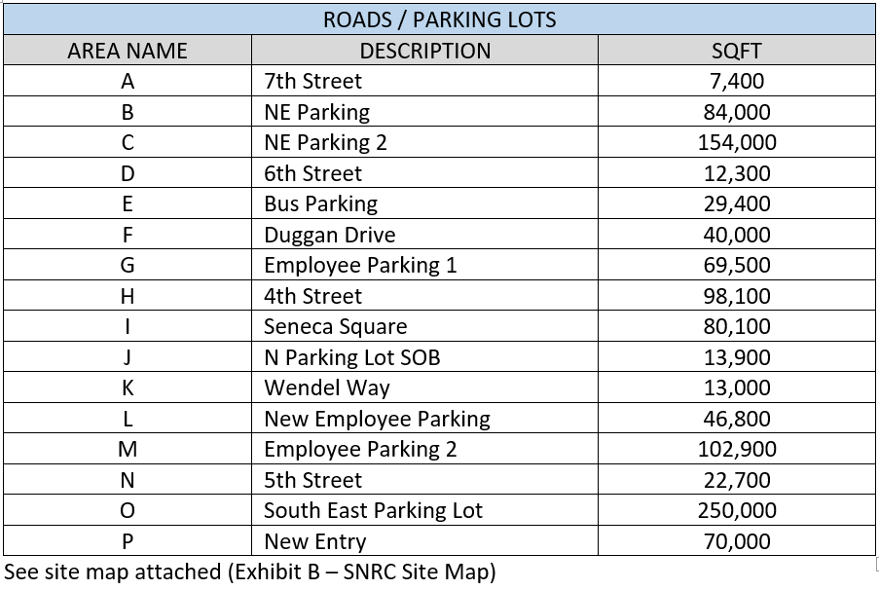

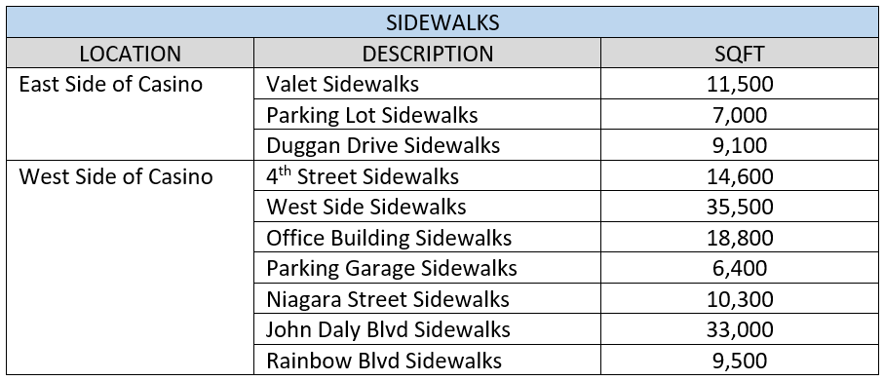

SENECA BUFFALO CREEK CASINO LOCATIONS Approximate SQFT

See Site Maps: Exhibit C pre-construction and Exhibit D post-construction

Scope of Services
- The complete plowing, piling, removal of snow and ice, distribution of ice-melting product and supply of rock salt as needed and as requested during the snow season.
- The Contractor will be expected to be on-call 24 hours a day, 7 days a week.
- The Contractor must coordinate all activities with Owner’s-Office of Facilities Management.
- Clearing of snow and ice from sidewalks shall only be performed by request of the property manager.
- The Contractor shall begin plowing during all snowfalls when the accumulation reaches a depth of approximately one inch (1”), when the Owner calls to notify, or when the property is unsafe, whichever occurs first.
- Contractor shall remove and keep snow, ice, and slush clear from all parking lot areas, garage entrances, sidewalks, and entrances to the property at all times. All piled snow that is temporarily staged is to be removed prior to each weekend or event as communicated to the Contractor by the Facilities department. The Facilities departments will communicate all areas where the contractors are able and that are allowable to pile snow.
- Contractor shall plow and spread ice-melting product as many times as necessary to keep the property cleaned of snow and ice and safe during and after snow and ice storms. Contractor shall keep all roadways open and passable throughout the snow storms.
- Contractor plowing shall be completed within (2) two feet of garage doors.
- Contractor shall keep the following areas clear at the end of the snow storm: along main roads, all building entrances and doors, fire and emergency exits, sidewalks, walkways, fire hydrants, storm drains, parking meter pay stations, public art, and utility boxes.
- Machinery for sidewalks must be less than 5’ wide. Shovels may be required for areas too small for machinery.

RFP Administrative Information

Contact Information
Please use the following name and email address for all correspondence concerning this RFP.
Name Shelle Heaton
Telephone (716) 345-1594
Email sheaton@senecacasinos.com

Schedule of Events
RFP issue date: 08/28/2026
Notification of Intent to Bid: 09/03/2026
Mandatory Site Tours*: SBCC – 9/4 at 9:30 AM
SNRC – 9/4 following SBCC
Bid Submission Deadline: 9/11/26
*Site Tour Instructions:
Attendance is mandatory for each property site visit. Please limit the number of associates attending the mandatory walkthrough to two (2) per company.
SBCC: Meet at the lobby inside the 1st floor parking ramp entrance at 1 Fulton St, Buffalo
SNRC: Meet at the Blues Restaurant at 310 4th St, Niagara Falls

Intent to Bid
Potential Bidders must submit an email confirming their intent to bid to the Facilitator by the date and time indicated in the above schedule of events.
Submission of the intent to bid notice constitutes the Potential Bidder’s acceptance of the RFP schedule, procedures evaluation criteria and other administrative instructions of this RFP.

Bidder Questions
Bidders must submit any questions to the Facilitator’s email address directly. No telephone questions will be accepted or considered.
Questions must reference the specific RFP paragraph number and page and quote the passage being questioned. SGC will respond to questions promptly and will send answers to Bidders as a group.

Submission of Proposals
Proposals must be submitted in electronic form, preferably in Microsoft Word and/or Microsoft Excel formats. Note: SGC’s email system rejects incoming messages with attachments exceeding 20 MB. Bidders are encourage to confirm that the Coordinating Buyer received their bid, prior to the bid submission deadline (date and time) indicated in the above schedule of events.
The Coordinating Buyer must receive proposals on or before the bid submission deadline. Proposals received after the bid submission deadline will not be considered.

Proposal Format
Send RFP response with all requested information answered in the format provided, along with any supporting attachments, electronically via email as stated in (above) Section E. Submission of Proposals.
Bidders must complete the attached excel workbook Exhibit A
In addition, the following documents must be sent with your RFP response:
Part-1 Bidder Representations and Certifications
A corporate officer or person who is authorized to represent Bidder must complete, sign and date the Bidder Certifications and Representations, Section VII of the RFP.
Part-2 Appendix
Appendix-A: Evidence of Insurance
Evidence of current insurance is to be provided to the satisfaction of SGC’s Risk Management Department. Insurance requirements vary depending upon the nature of the services and the degree of risk. Standard requirements include minimum $5 million general liability coverage (per occurrence and in the aggregate) [$10 million for construction-related contracts], $1 million automobile liability coverage, combined single limit, for all vehicles brought on-site, worker’s compensation and employer liability insurance in accordance with state law. Additional types of insurance, including, without limitation, professional liability insurance and network privacy/data security/cyber liability insurance, may be required in specific circumstances. SGC and related persons and entities will be additional insured under the general liability and automobile liability policies of insurance.
SGC’s Risk Management Department has discretion to increase, decrease, or dispense with insurance in appropriate cases. They may, in addition to or instead of insurance, require signature of a Waiver, Indemnification and Hold Harmless form by any individuals who will be present on SGC property.
Additional Insured language:
Seneca Gaming Corporation and their parent, Subsidiaries, Directors, Officers, Agents, representatives and Employees are named as Additional Insures on the General Liability and Automobile Liability policies. A waiver of subrogation applies on all policies, including Employer’s Liability, in favor of Seneca Gaming Corporation.
Seneca Gaming Corporation to be named as Certificate Holder:
Seneca Gaming Corporation
310 Fourth Street
Niagara Falls, NY 14303
Certificates evidencing such coverage shall be provided prior to commencement of work and renewal certificates shall be provided upon availability.
SGC’s Risk Management Department has discretion to increase, decrease, or dispense with insurance in appropriate cases. They may, in addition to or instead of insurance, require signature of a Waiver, Indemnification and Hold Harmless form by any individuals who will be present on SGC property.
For additional details, see section 22 of SGC’s Standard Terms & Conditions at https://senecacasinos.com/media/zqdd2j1f/sgc-standard-terms-and-conditions-v-10-30-20.pdf
Appendix-B: Standard Agreements
Bidders are invited to include their standard form of agreement (preferably in Word format) to form the basis of the contract should it be awarded to them. However, SGC reserves the right to utilize its own standard form of agreement.
Part-3 Company Overview
Section 1: Company Overview
Provide a brief description of the overall organization of your company including the location of corporate headquarters, primary industries and markets served, how long the company has been in business and what experience your company has serving multi property and Native American-owned casinos and casino resorts, if any.
Section 2: References
Include a minimum of three contracts for goods or services similar to those in the RFP’s Requirement Specifications that were awarded within the last three (3) years, along with contact information for each client reference. Wherever possible, include casino and casino-resort clients in these references.
Part-4 RFP Proposal
Section 1: Executive Summary
The purpose of this section is to summarize your proposal for SGC evaluators and decision makers. The summary should include, at minimum, key proposal elements, your vectors of competitive differentiation and an overview of your pricing model.
Section 2: Response to Requirements
Include complete responses to all requirements outlined in the Requirements Specification section of this RFP. Reponses are to follow the outline of the Requirements Specification herein (including companion documents, if any) and refer to each requirement being addressed. Requirements that cannot be supported in whole or in part should be identified as such.
Section 3: Bidder Supplemental Information
The purpose of this section is to afford Bidder an opportunity to present necessary information that was not requested. Use this section to indicate, for example, alternative methodology or additional functionality that may be outside the scope of the RFP but could enhance the value of services delivered or potential issues that are relevant to the RFP and your proposal.
Section 4: Product and Service Delivery
This section summarizes for your standard fulfillment processes, including delivery scheduling, response to emergency orders, disaster recovery and equipment installation, maintenance, repair and replacement plans.
Part-5 Pricing Proposal and Quotes
Section 1: Pricing Model and Terms
This section summarizes Bidder’s pricing model and applicable terms. Additional offers, discounts, rebates, etc. should be noted separately. Where applicable, pricing should cover the entire term of the contract indicated in the RFP, including any options to renew, where applicable.

Conditions
Under no circumstances will responses be made available to other organizations, either wholly or in part, without Vendor’s prior written permission.
By participating in this RFP:
- Bidder agrees that you will not directly contact any SGC employee without prior written approval from SGC. Failure to do so may revoke your invitation to participate in this RFP.
- Bidder agrees to keep confidential all information related to this RFP. Any sharing of this information without express permission will exclude Vendor from consideration. This RFP and all supporting attachments and related communications may not be duplicated or distributed in any form to any other company without prior written permission.
Bidder agrees that all information provided in their RFP response is valid for a minimum of 90 days from the response date.
All costs incurred by the bidder for participating in this evaluation will be the responsibility of the bidder. SGC will not reimburse any bidder costs or expenses.
All responses to the RFP become the property of SGC.

Proposal Evaluation/Vendor Selection
Proposals will be evaluated to determine their completeness and compliance with the mandatory requirements and qualifications specified throughout this document. Failure to comply with one or more of these requirements may result in the proposal being rejected as non-responsive. SGC reserves the right to waive deviations it deems non-material and/or to reject any and all Proposals in its sole discretion.
The successful Bidder(s) will be notified by email of the award of contract, conditional upon appropriate licensure through SGC’s regulatory authority, the Seneca Gaming Authority (“SGA”), providing proof of insurance to the satisfaction of SGC’s Risk Management Department, and signature of a contract and/or issue of a Purchase Order. It is only following all of these actions that the successful Bidder will be considered a Vendor of SGC.
Successful Bidders must complete SGC’s Vendor Registration Form and W-9 (or equivalent for non-U.S. persons/entities). If required, they must also complete and submit to the SGA the requisite vendor license application. They are also responsible for payment of SGA processing or vendor license fees plus the Seneca Nation of Indians Business License fee as detailed in paragraph VI. I. below. Fees range from $750 to $2,500 depending upon the nature of the services. These requirements must be completed and, if applicable, the requisite SGA vendor license issued, prior to signature of the contract. Vendor licenses and fees must be renewed every two years. SGA may also, in an appropriate case, require the licensure of individual employees who perform certain services that are or may be closely associated with SGC’s casino operation. As SGA retains the discretion to make this type of determination on a case-by-case basis, SGC is unable at the RFP point in the bidding process to state definitively whether such licensure will be required in any particular case.

General Bidder Information
This RFP does not commit SGC to award a contract, to pay any costs incurred in the preparation of the RFP, nor to procure or contract for services or supplies.
It is the policy of SGC that all Proposals are to be held unopened and confidential until after the closing date and time. At the bid opening, Proposals will be opened by the contact Coordinating Buyer and are reviewed by a compliance representative.
Bid Validity. Bidder’s bid submission must remain valid for a minimum of ninety (90) days from the bid closing date.
Minority Bidders: SGC gives priority to Bidders who are Native American, minority, women-owned or small disadvantaged businesses. If your company falls into any of these categories or has contracted with such businesses for the purpose of the proposal, please note as such on your proposal.
Alternative Proposals (if applicable) are accepted based on the following conditions: SGC will consider alternative proposals from Bidders provided they have submitted a response based on the original requirements. The alternative Proposal will be submitted separate and apart from the basic Proposal. It is assumed that the materials included in the alternative Proposal meet all of the qualifications of the original Proposal.
Substitutes. Any recommended substitutions should be attached separately. Products may require testing before acceptance. Bidder’s pricing must include the conversion calculations if your size, pack, weight, etc. is not the same as the specified product(s). SGC solicits Bidders’ recommendation(s) for new products and/or services leading to lower costs.
Projected Volume. Bidders are advised that the volumes or quantities indicated on the RFP are for reference purposes only and must not be taken as guaranteed or as constituting representations by SGC. Actual volume and quantities may vary depending upon the needs of the SGC departments or business units for which the goods and/services are destined and fluctuations in the business cycle.

SGC Standard Terms and Conditions
Any purchase order or contract flowing from this RFP (in the absence of language to the contrary in the contract) is subject to the terms and conditions hereof as well as to Seneca Gaming Corporation’s Standard Terms and Conditions which are available on the following website: https://senecacasinos.com/media/zqdd2j1f/sgc-standard-terms-and-conditions-v-10-30-20.pdf.
Reference to, or inclusion of, the Bidder’s preprinted terms and conditions with Bidder’s Proposal will not be considered as an exception to SGC Terms and Conditions.

Provisions Applicable to the Contract

Agreement Term
The initial term of the contract will be three years, with two options to renew in favor of SGC, each (1) year in duration (each a renewal term).
Upon expiration of the initial term and exercised renewal terms, the contract will automatically renew on a month-to-month basis, as needed to facilitate a new RFP and enter (or transition) into a subsequent new agreement.

Requirements Specification

Ice-Melting Products
Roads and Parking Lots
  - Unless otherwise specified by the property manager, all roads and parking lots are to be spread with sodium chloride (rock salt).
Sidewalks / Walkways
  - Use of snow and ice-melting chemicals on concrete and brick paved surfaces shall be restricted to the products below, depending on location, per direction from the property manager.
    - Calcium Chloride (concrete must be at least 6 months old)
    - Sodium Chloride (rock salt)

Piling of Snow and Removal of Snow:
- Contractor shall pile snow in such a way to minimize the blockage of stairs, walkways and parking spaces.
- Contractor shall pile snow in areas approved or designated by owner’s Agent. Accumulation of snow piles over long periods of time must be avoided.

Staking of Areas:
- Contractor shall be responsible for staking, maintaining and removing stakes for all landscape islands, fire hydrants and other areas that could be damaged by the Contractor to minimize the likelihood of damage and clearly identify those areas where access needs to be maintained. This work must be completed by October 15th each contract year and removed by April 15th at the end of the snow and ice season.
- Contractor will mark all hydrants with tall enough stakes so they can be visible at all times and Contractor will take care not to bury any safety devices such as hydrants, road markers, signs, etc.
- Contractor shall be required to make arrangements satisfactory to Owner’s Agent to remove all stakes and markers of each contract year.

Property Damages:
- Contractor shall be responsible for damage(s) to the Property (signs, railings, light poles, fences, trees, curbing, plants and grass) resulting from Contractor’s services.
- Contractor will inspect the Property for pre-existing damage and submit a report detailing all pre-existing damage by November 1st of each contract year. Owner’s Agent will review and renew this report with Contractor.
- Contractor is responsible for reporting all damage(s) in writing within (72) seventy-two hours of each occurrence.
- Contractor shall be required to make arrangements satisfactory to Owner’s Agent to repair damage(s) to property.
- Contractor shall hold and save harmless the Owner and Owner’s Agent from all claims by tenants or others whose personnel or property may be damaged or injured by Contractor, their employees and included but not limited to the use of equipment and materials.
- Contractor shall make reasonable and prompt restitution by cash, replacement or repairs, subject to the approval of the Owner’s Agent, for any damages for which the Contractor is liable for which the Owner’s Agent shall be sole judge.

Emergency Contacts and Response Time:
- Contractor shall provide emergency telephone numbers that may be called any time, 24 hours a day, (7) seven days a week during the snow and ice season.
- Contractor shall respond within (1) one hour to any call made by Owner or Owner’s Agent for snow removal services.

Contractor’s Employees:
- Contractor shall ensure that all of their employees and agents shall abide by all safety rules and regulations, which may be promulgated from time to time by either party as they pertain to the Contractor’s operations (including those applicable to the disadvantaged). The Contractor will also be responsible for conducting regularly scheduled safety meetings with all employees, as per any federal, State and/or local regulations.
- Contractor shall comply, at all times, with any and all local, State or Federal rules, regulations and laws regarding anti-discrimination and equal opportunity in employment.
- Contractor shall employ only licensed, competent and satisfactory personnel and shall provide a sufficient number of employees to perform the required services efficiently and in a manner satisfactory to the Owner’s Agents. If the Contractor is notified in writing that any person employed in the execution of this agreement is in the Owner’s Agent’s opinion, incompetent, disorderly, or otherwise unsatisfactory, such person shall not again be employed in the execution of this contract without the written consent of the Owner’s Agent/Contract Administrator.
- Contractor’s employees shall be neat and clean in appearance while on duty, and when reporting to or exiting the property.

Contractor’s Equipment and Labor:
- Contractor shall supply all labor, snowplows, front-end loaders, dump trucks, snow blowers, sidewalk plows, shovels and safety equipment. The Contractor shall keep 2 loaders with pushers on site for use at SNRC and one loader with pusher for use on site at SBCC at all times during the snow season.
- Owner’s Agent expects to and the Contractor will agree to a thorough inspection by Owner’s Agent of all work and equipment furnished under this contract.
- Contractor shall have adequate equipment to service all areas under this contract. Plow trucks shall be equipped with a plow and salting units which will be capable of uniformly distributing on roadways and parking lot surfaces and shall be equipped with controls that provide varying application rates.
- Breakdowns, Other Failures and Backup Equipment: Contractor shall keep vehicles and equipment operational at all times throughout the contract period. Contractor shall immediately contact Owner’s Agent/Contract Administrator to report any breakdowns. In the event of equipment breakdown that cannot be repaired within (2) two hours, a replacement must be supplied without delay until the repairs can be completed. Complete descriptions of all backup equipment must be submitted in the Contractor’s bid. Backup equipment must be readily available at all times.
- If the Contractor fails to provide snow plowing, snow removal and salting services for any reason, the Owner’s Agents/Contract Administrator shall complete the work as required and shall deduct the direct costs from monies due.
- Contractor shall supply a full-time supervisor acceptable to Owner’s Agent who will have the authority to immediately execute orders given by the Owner’s Agent. Contractor’s office management and job supervisors will be responsible for the quality of the work performed and must be available on a 24-hour basis. In addition, the Contractor will supply one account manager, who will be solely dedicated to this contract and account and will service as the main contact person for the Owner’s Agent.
- Contractor shall ensure that their employees and agents conform to all Federal (OSHA), State and Municipal safety and health regulations and shall assume full responsibility for any violations and/or non-compliance with such regulations.
- Under no circumstances may the plowing, piling or salting be subcontracted to another contractor.

Snow Removal Quantification
Payment for snow hauling shall be based on actual documented snow removed, not solely on theoretical snowfall calculations derived from snowfall depth and property area. While National Weather Service snowfall data may be used to estimate expected snow accumulation, it shall not be the sole basis for invoicing snow hauling services.

Required Documentation- for each snow hauling event, the contractor must provide:
- Date and time of each load.
- Unique truck identification number.
- Driver name.
- Truck type (single axle, tandem axle, tri-axle, etc.).
- Certified truck bed capacity in cubic yards.
- Number of loads hauled by each truck.
- Disposal location for each load.
- Start and finish times for each truck.
- Daily equipment and operator activity logs.
Verification- SGC reserves the right to verify all invoiced quantities through:
- Surveillance camera footage.
- Vehicle counts.
- Security observations.
- Spot inspections.
- Independent audits.
Invoices that cannot be supported by documentation may be adjusted or rejected.

Snow Hauling Capacity
- Each contractor shall submit certified hauling capacities for every truck proposed for use.
- For billing purposes, payment will be based on the documented capacity of each truck unless otherwise approved in writing.
- Overloaded or estimated truck capacities will not be accepted.

Snowfall Estimates
Snowfall depth calculations may be used only for planning and operational purposes.
Theoretical volume calculations generated from snowfall depth multiplied by surface area shall not constitute proof of hauled quantities.

Salt Application Documentation
Each salt application shall include:
- Date and time.
- Air temperature.
- Pavement temperature (when available).
- Weather conditions.
- Areas treated.
- Tons of salt applied.
- Type of de-icing material used.
- Equipment utilized.
- Operator name.
- Bulk salt deliveries may be audited against application records.

Electronic Reporting
The successful contractor shall provide electronic reports within 24 hours of each weather event, including:
- Equipment utilized.
- Labor hours.
- Truckload counts.
- Salt usage.
- Photographs before and after service when requested.

Pricing
Please provide your most competitive pricing and any additional offers. Prices are fixed during the term of the contract, including any renewal term.
Pricing is to be submitted utilizing the PRICING tab in ‘Exhibit A – Snow Removal for SNRC and SBCC’.
Contractor will submit the following base amounts with their bid:
- Contractor shall supply tons of salt for the salting of parking lots and other designated areas. All salt required after the depletion of the supply will be paid by Owner’s Agent by a unit cost agreeable by both parties (Contractor and Owner’s Agent/Contract Administrator).
- Offsite removal of snow up to (tonnage allowance) will be included in the contract price.
- Additional off-site removal of snow over (yardage allowance) will be unit priced and charges associated with Contractor’s use of a pay loader, bobcat, and/or dump truck must be first approved by the Owner’s Agent.
In addition to pricing submitted in Exhibit A, alternative pricing models may be submitted as a separate attachment

Tax Exempt Status
Seneca Gaming Corporation is a governmental instrumentality of the Seneca Nation of Indians all of whose operations (except for its golf course) are on sovereign Seneca Territory. SGC will provide a New York State tax exemption certificate issued in the name of the Seneca Nation of Indians, as applicable.

Payment Terms
SGC standard payment terms are Net 30 days after delivery of goods and/or services and receipt of a correct invoice. Bidder is encouraged to indicate any additional early payment/ discount terms in its Proposal. It is the policy of SGC not to provide deposits unless significant discounts or special circumstances apply.

Supplemental Bidder Information

Business Continuity
For RFP’s involving strategic commodities/services, provide an overview of your disaster recovery/business continuity plan (the “Plan”). The Plan indicates how Bidder minimizes the risk of interruption to Bidder’s ability to provide the goods and/or services contemplated in this RFP in the event of specified occurrence; Bidder’s critical supplier strategy to ensure continuity of suppliers in such event; and Bidder’s process or criteria for prioritizing customer demands during a crisis.

Conformity of Proposal with SGC Requirements
Bidders represent and warrant that the goods and/or services provided in their Proposal will meet SGC’s requirements as expressed in the Scope of Work contained in this RFP and will be fit for the purpose expressed herein.

Vendor Requirements

Proposal
Successful Bidders should expect that their response to the RFP and any accompanying supporting materials will be incorporated into any contract signed with SGC.

Standard Service Agreement
Successful Bidder will be expected to sign SGC’s standard services agreement, subject to such changes as are necessary to reflect the terms of this RFP and Successful Bidder’s bid or proposal, and such further changes as the parties, acting reasonably, may agree.

Seneca Nation Business Registration Fee (SNIBRF)
Vendor must pay the SNIBRF of $750 directly to the Seneca Gaming Authority once total payment to the vendor exceeds $10,000. Failure to pay the fee when required may result in termination of further business with Seneca Gaming Corporation.

Bidder Certifications and Representations
Bidder is a reputable company fully qualified and regularly engaged in providing products and/or services necessary to meet the terms, conditions and requirements of the RFP.
Bidder is aware of, is fully informed about, and is in full compliance with all applicable federal, state and local laws, rules, regulations and ordinances.
Bidder understands the requirements and specifications set forth in this RFP and affirms that no compensation has been received for participation in the preparation of the specifications for this RFP.
- Bidder has reviewed and understood SGC’s Standard Terms & Conditions found at https://senecacasinos.com/media/zqdd2j1f/sgc-standard-terms-and-conditions-v-10-30-20.pdf
Bidder represents and warrants that all goods and services quoted in response to this RFP will meet or exceed the safety standards established and promulgated under the Federal Occupational Safety and Health Law (Public Law 91-596) and its regulations in effect or proposed as of the date of this solicitation.
All statements, information and representations prepared and submitted in response to this RFP are current, complete, true and accurate. Bidder acknowledges that SGC will rely on such statements, information and representations in selecting the Awarded Vendor. If selected by SGC as the Awarded Vendor, Bidder will notify SGC immediately of any material change in any matters with regard to which Bidder has made a statement or representation or provided information.
I, the undersigned, hereby certify that I am authorized to sign as a representative for the Bidder listed below:
Legal Name of Bidder: ___________________________________________________
DBA (if applicable): _____________________________________________________
Address: ______________________________________________________________
Telephone: ____________________
E-Mail: _______________________________________________________________
Website: ______________________________________________________________
Representative’s Signature: _______________________________________________
Representative’s Printed Name: ____________________________________________
Representative’s Printed Title: _____________________________________________
Date: __________________ NAICS code # ______________________

