Seneca Gaming Corporation


On-call Pavement Maintenance Services
RFP # SGC-0063-26SDH

April 27, 2026
Confidential

Table of Contents
I. Introduction 2
II. RFP Objective 2
III. Scope of Services 2
IV. RFP Administrative Information 2
A. Contact Information 2
B. Schedule of Events 2
C. Intent to Bid 2
D. Bidder Questions 2
E. Submission of Proposals 2
F. Proposal Format 3
G. Conditions 5
H. Proposal Evaluation/Vendor Selection 5
I. General Bidder Information 6
J. SGC Standard Terms and Conditions 6
V. Provisions Applicable to the Contract 6
A. Agreement Term 6
B. Requirements Specification 6
C. Pricing 7
D. Tax Exempt Status 7
E. Payment Terms 7
VI. Supplemental Bidder Information 7
A. Conformity of Proposal with SGC Requirements 7
VII. Vendor Requirements 7
A. Proposal 7
B. Tribal Employment Rights Office (“TERO”) Ordinance 7
C. Standard Service Agreement 7
D. Seneca Nation Business Registration Fee (SNIBRF) 8
VIII. Bidder Certifications and Representations 9

Introduction
Seneca Gaming Corporation is a wholly owned, tribally chartered corporation of the Seneca Nation of Indians (the “Nation”) which operates all of the Nation’s Class III gaming operations in Western New York.
Seneca Gaming Corporation, through its wholly owned subsidiaries, owns and operates Seneca Niagara Resort & Casino in Niagara Falls, New York, Seneca Allegany Resort & Casino in Salamanca, New York, and Seneca Buffalo Creek Casino in Buffalo, New York.
For additional information, please visit our website at www.Senecacasinos.com.

RFP Objective
Seneca Gaming Corporation (hereinafter referred to as SGC) is seeking proposals from qualified vendors to provide professional pavement maintenance services for our casino properties. The selected vendor will enter into a 3-5 year On-call Master Services Agreement (MSA) ensuring quality, efficiency, and the ability to meet the unique needs of each property as they are needed.
Statements of work will be created for individual projects through the contract term.

Scope of Work

Services included but not limited to:

Routine Pavement Maintenance

Crack sealing

Sealcoating

Sweeping and debris removal

Pavement Repair

Patching and resurfacing

Replacement of damaged sections

Pavement Inspection and Assessment*

Regular assessments and reporting on pavement conditions

Recommendations for long-term maintenance strategies

Emergency Services

Prompt response to pavement-related emergencies

B. Square Footage (approximate)

Niagara Falls 1,020,296

Buffalo 209,839

Allegany 583,085

C. Annually*
Contractor should have yearly site visits and assess the conditions of all asphalt roadways and parking lots and submit a proposal to maintain the conditions of the asphalt as preventative maintenance. This visit should take place in the spring with work being complete before the 4th of July holiday.

D. Resurfacing as Needed/Requested:

Mill roadway down 1.5”

Clean and prep surfaces, protecting drain and utility covers

Apply tack

Shim low areas with 7F blacktop

Install 1.5” 7F blacktop

Roll to a smooth even finish

May use I-D2 for top coat in some areas

Layout and stripe

Striping should include parking ramp, crosswalks, directional arrows, etc.

Crack seal using strike off method (apply crack seal then strike off using v style squeegee to flatten band).

Mastic Crack Seal – cracks too large to seal but too small to mill and pave.

Curb repairs and catch basin repairs

RFP Administrative Information

Contact Information
Please use the following name and email address for all RFP correspondence:

Name Shelle Heaton

Telephone (716) 345-1594

Email sheaton@senecacasinos.com

Schedule of Events

RFP issue date: 04/27/2026

Intent to Bid: 05/04/2026

Bidder Questions Due 05/04/2026

Bid Submission Deadline: 05/11/2026

Intent to Bid
Potential Bidders must submit an email confirming their intent to bid to the Facilitator by the date and time indicated in the above schedule of events.
Submission of the intent to bid notice constitutes the Potential Bidder’s acceptance of the RFP schedule, procedures evaluation criteria and other administrative instructions of this RFP.

Bidder Questions and Request for Walkthrough
Bidders must submit any questions to the Facilitator’s email address directly. No telephone questions will be accepted or considered.
Questions must reference the specific RFP paragraph number and page and quote the passage being questioned. SGC will respond to questions promptly and will send answers to Bidders as a group.

Walkthroughs are not mandatory; however, bidders may request to have one. If requested, the walkthrough(s) will be scheduled. The walkthrough(s) will not be a Q&A session; any and all questions will be required in writing and will be shared with all bidders. An updated Schedule of Events will be provided after all walkthrough(s) are confirmed.

Submission of Proposals
Proposals must be submitted in electronic form, preferably in Microsoft Word and/or Microsoft Excel formats. Note: SGC’s email system rejects incoming messages with attachments exceeding 20 MB. Bidders are encourage to confirm that the Coordinating Buyer received their bid, prior to the bid submission deadline (date and time) indicated in the above schedule of events.
The Coordinating Buyer must receive proposals on or before the bid submission deadline. Proposals received after the bid submission deadline will not be considered.

Proposal Format
Send RFP response with all requested information answered in the format provided, along with any supporting attachments, electronically via email as stated in (above) Section E. Submission of Proposals.
Bidders must complete the attached excel workbook - Exhibit A
In addition, the following documents must be sent with your RFP response:
Part-1 Bidder Representations and Certifications
A corporate officer or person who is authorized to represent Bidder must complete, sign and date the Bidder Certifications and Representations, Section VII of the RFP.
Part-2 Appendix
Appendix-A: Evidence of Insurance
Evidence of current insurance is to be provided to the satisfaction of SGC’s Risk Management Department. Insurance requirements vary depending upon the nature of the services and the degree of risk. Standard requirements include minimum $5 million general liability coverage (per occurrence and in the aggregate) [$10 million for construction-related contracts], $1 million automobile liability coverage, combined single limit, for all vehicles brought on-site, worker’s compensation and employer liability insurance in accordance with state law. Additional types of insurance, including, without limitation, professional liability insurance and network privacy/data security/cyber liability insurance, may be required in specific circumstances. SGC and related persons and entities will be additional insured under the general liability and automobile liability policies of insurance.
SGC’s Risk Management Department has discretion to increase, decrease, or dispense with insurance in appropriate cases. They may, in addition to or instead of insurance, require signature of a Waiver, Indemnification and Hold Harmless form by any individuals who will be present on SGC property.
Additional Insured language:
Seneca Gaming Corporation and their parent, Subsidiaries, Directors, Officers, Agents, representatives and Employees are named as Additional Insures on the General Liability and Automobile Liability policies. A waiver of subrogation applies on all policies, including Employer’s Liability, in favor of Seneca Gaming Corporation.
Seneca Gaming Corporation to be named as Certificate Holder:
Seneca Gaming Corporation
310 Fourth Street
Niagara Falls, NY 14303
Certificates evidencing such coverage shall be provided prior to commencement of work and renewal certificates shall be provided upon availability.
SGC’s Risk Management Department has discretion to increase, decrease, or dispense with insurance in appropriate cases. They may, in addition to or instead of insurance, require signature of a Waiver, Indemnification and Hold Harmless form by any individuals who will be present on SGC property.
For additional details, see section 22 of SGC’s Standard Terms & Conditions at https://senecacasinos.com/media/zqdd2j1f/sgc-standard-terms-and-conditions-v-10-30-20.pdf
Appendix-B: Standard Agreements
Bidders are invited to include their standard form of agreement (preferably in Word format) to form the basis of the contract should it be awarded to them. However, SGC reserves the right to utilize its own standard form of agreement.
Part-3 Company Overview
Section 1: Company Overview
Provide a brief description of the overall organization of your company including the location of corporate headquarters, primary industries and markets served, how long the company has been in business and what experience your company has in pavement maintenance, particularly for commercial properties.
Section 2: References
Include a minimum of three contracts for goods or services similar to those in the RFP’s Requirement Specifications that were awarded within the last three (3) years, along with contact information for each client reference. Wherever possible, include casino and casino-resort clients in these references.
Part-4 RFP Proposal
Section 1: Executive Summary
The purpose of this section is to summarize your proposal for SGC evaluators and decision makers. The summary should include, at minimum, key proposal elements, your vectors of competitive differentiation, an overview of your pricing model and your knowledge of applicable regulations and industry standards.
Section 2: Response to Requirements
Include complete responses to all requirements outlined in the Requirements Specification section of this RFP. Reponses are to follow the outline of the Requirements Specification herein (including companion documents, if any) and refer to each requirement being addressed. Requirements that cannot be supported in whole or in part should be identified as such.
Section 3: Bidder Supplemental Information
The purpose of this section is to afford Bidder an opportunity to present necessary information that was not requested. Use this section to indicate, for example, alternative methodology or additional functionality that may be outside the scope of the RFP but could enhance the value of services delivered or potential issues that are relevant to the RFP and your proposal.
Section 4: Product and Service Delivery
This section summarizes for your standard fulfillment processes, including delivery scheduling, response to emergency orders, disaster recovery and equipment installation, maintenance, repair and replacement plans.
Part-5 Pricing Proposal and Quotes
Section 1: Pricing Model and Terms
This section summarizes Bidder’s pricing model and applicable terms. Additional offers, discounts, rebates, etc. should be noted separately. Where applicable, pricing should cover the entire term of the contract indicated in the RFP, including any options to renew, where applicable.

Conditions
Under no circumstances will responses be made available to other organizations, either wholly or in part, without Vendor’s prior written permission.
By participating in this RFP:
- Bidder agrees that you will not directly contact any SGC employee without prior written approval from SGC. Failure to do so may revoke your invitation to participate in this RFP.
- Bidder agrees to keep confidential all information related to this RFP. Any sharing of this information without express permission will exclude Vendor from consideration. This RFP and all supporting attachments and related communications may not be duplicated or distributed in any form to any other company without prior written permission.
Bidder agrees that all information provided in their RFP response is valid for a minimum of 90 days from the response date.
All costs incurred by the bidder for participating in this evaluation will be the responsibility of the bidder. SGC will not reimburse any bidder costs or expenses.
All responses to the RFP become the property of SGC.

Proposal Evaluation/Vendor Selection
Proposals will be evaluated to determine their completeness and compliance with the mandatory requirements and qualifications specified throughout this document. Failure to comply with one or more of these requirements may result in the proposal being rejected as non-responsive. SGC reserves the right to waive deviations it deems non-material and/or to reject any and all Proposals in its sole discretion.
The successful Bidder(s) will be notified by email of the award of contract, conditional upon appropriate licensure through SGC’s regulatory authority, the Seneca Gaming Authority (“SGA”), providing proof of insurance to the satisfaction of SGC’s Risk Management Department, and signature of a contract and/or issue of a Purchase Order. It is only following all of these actions that the successful Bidder will be considered a Vendor of SGC.
Successful Bidders must complete SGC’s Vendor Registration Form and W-9 (or equivalent for non-U.S. persons/entities). If required, they must also complete and submit to the SGA the requisite vendor license application. They are also responsible for payment of SGA processing or vendor license fees plus the Seneca Nation of Indians Business License fee as detailed in paragraph VI. I. below. Fees range from $750 to $2,500 depending upon the nature of the services. These requirements must be completed and, if applicable, the requisite SGA vendor license issued, prior to signature of the contract. Vendor licenses and fees must be renewed every two years. SGA may also, in an appropriate case, require the licensure of individual employees who perform certain services that are or may be closely associated with SGC’s casino operation. As SGA retains the discretion to make this type of determination on a case-by-case basis, SGC is unable at the RFP point in the bidding process to state definitively whether such licensure will be required in any particular case.

General Bidder Information
This RFP does not commit SGC to award a contract, to pay any costs incurred in the preparation of the RFP, nor to procure or contract for services or supplies.
It is the policy of SGC that all Proposals are to be held unopened and confidential until after the closing date and time. At the bid opening, Proposals will be opened by the contact Coordinating Buyer and are reviewed by a compliance representative.
Bid Validity. Bidder’s bid submission must remain valid for a minimum of ninety (90) days from the bid closing date.
Minority Bidders: SGC gives priority to Bidders who are Native American, minority, women-owned or small disadvantaged businesses. If your company falls into any of these categories or has contracted with such businesses for the purpose of the proposal, please note as such on your proposal.
Alternative Proposals (if applicable) are accepted based on the following conditions: SGC will consider alternative proposals from Bidders provided they have submitted a response based on the original requirements. The alternative Proposal will be submitted separate and apart from the basic Proposal. It is assumed that the materials included in the alternative Proposal meet all of the qualifications of the original Proposal.
Projected Volume. Bidders are advised that the volumes or quantities indicated on the RFP are for reference purposes only and must not be taken as guaranteed or as constituting representations by SGC. Actual volume and quantities may vary depending upon the needs of the SGC departments or business units for which the goods and/services are destined and fluctuations in the business cycle.

SGC Standard Terms and Conditions
Any purchase order or contract flowing from this RFP (in the absence of language to the contrary in the contract) is subject to the terms and conditions hereof as well as to Seneca Gaming Corporation’s Standard Terms and Conditions which are available on the following website: https://senecacasinos.com/media/zqdd2j1f/sgc-standard-terms-and-conditions-v-10-30-20.pdf.
Reference to, or inclusion of, the Bidder’s preprinted terms and conditions with Bidder’s Proposal will not be considered as an exception to SGC Terms and Conditions.

Provisions Applicable to the Contract

Agreement Term
The initial term of the contract will be three years, with two options to renew in favor of SGC, each (1) year in duration (each a renewal term).
Upon expiration of the initial term and exercised renewal terms, the contract will automatically renew on a month-to-month basis, as needed to facilitate a new RFP and enter (or transition) into a subsequent new agreement.

Requirements
- Bidder must submit a detailed cost proposal for the scope of work, including all direct and indirect costs.
- Rates, pricing, terms, and conditions identified in the On Call Master Agreement will apply.
- Bidder shall submit a summary of the tasks along with estimates of how many hours and cost they propose will be required to complete each activity.
- Include number and frequency of meetings anticipated.
- Please include how much notice is required before being able to start, if awarded the bid.
- Any exclusion of services must be clearing outlined.
- Contractor must have the ability to coordinate the crack filling, resurfacing, and striping of existing asphalt pavement at the locations indicated.
- Contractor should make recommendations of either seal coat, slurry seal or micro-surfacing based on Owner’s needs. Include specifications of product. Short cure times are preferred in order to allow for quicker turnaround.
- Include price per pound for Mastic Crack Seal and per gallon for crack sealer.
- Contractor will be responsible for traffic control and safety.
- All square footage provided is approximate. Contractor is required to measure all locations for exact square footage.
- Include your square foot price for milling and asphalt in order to accommodate for any unforeseen work.
- Include material and work warranties

Pricing
Master Agreement to include list of positions and, if possible, staff members who are available for services depending on the Statement of Work (SOW). Rates will be included and will apply to specific SOWs. Other expenses (general or specific) should be included in proposal. TERO fees (when needed) should be listed separately.

Tax Exempt Status
Seneca Gaming Corporation is a governmental instrumentality of the Seneca Nation of Indians all of whose operations (except for its golf course) are on sovereign Seneca Territory. SGC will provide a New York State tax exemption certificate issued in the name of the Seneca Nation of Indians, as applicable.

Payment Terms
SGC standard payment terms are Net 30 days after delivery of goods and/or services and receipt of a correct invoice. Bidder is encouraged to indicate any additional early payment/ discount terms in its Proposal. It is the policy of SGC not to provide deposits unless significant discounts or special circumstances apply.

Supplemental Bidder Information

Conformity of Proposal with SGC Requirements
Bidders represent and warrant that the goods and/or services provided in their Proposal will meet SGC’s requirements as expressed in the Scope of Work contained in this RFP and will be fit for the purpose expressed herein.

Vendor Requirements

Proposal
Successful Bidders should expect that their response to the RFP and any accompanying supporting materials will be incorporated into any contract signed with SGC.

Tribal Employment Rights Office (“TERO”) Ordinance
The Seneca Gaming Corporation and its subsidiaries comply with the Seneca Nation of Indians TERO Ordinance which may require a TERO Compliance Plan to be submitted to the TERO Office prior to completing any work on-site. Contact the Seneca Nation of Indians TERO Compliance Office at 716-532-4900 ext. 5413 or Route 438 Irving, NY 14081. The intent of the TERO Ordinance is to increase employment for Native American workers and businesses. A copy of the TERO Ordinance may be obtained from the TERO Office. SGC is not responsible for providing notice or information to Awarded Vendors concerning TERO matters; rather, it is the Awarded Vendors’ sole responsibility to contact the TERO Compliance Office to ensure compliance, when applicable. Where applicable the TERO office will assess a fee equal to 5% of the contract price. The TERO fee, where applicable, should be shown as a separate line item in the pricing proposal.

Standard Service Agreement
Successful Bidder will be expected to sign SGC’s standard services agreement, subject to such changes as are necessary to reflect the terms of this RFP and Successful Bidder’s bid or proposal, and such further changes as the parties, acting reasonably, may agree.

Seneca Nation Business Registration Fee (SNIBRF)
Vendor must pay the SNIBRF of $750 directly to the Seneca Gaming Authority once total payment to the vendor exceeds $10,000. Failure to pay the fee when required may result in termination of further business with Seneca Gaming Corporation.

Bidder Certifications and Representations
Bidder is a reputable company fully qualified and regularly engaged in providing products and/or services necessary to meet the terms, conditions and requirements of the RFP.
Bidder is aware of, is fully informed about, and is in full compliance with all applicable federal, state and local laws, rules, regulations and ordinances.
Bidder understands the requirements and specifications set forth in this RFP and affirms that no compensation has been received for participation in the preparation of the specifications for this RFP.
- Bidder has reviewed and understood SGC’s Standard Terms & Conditions found at https://senecacasinos.com/media/zqdd2j1f/sgc-standard-terms-and-conditions-v-10-30-20.pdf
Bidder represents and warrants that all goods and services quoted in response to this RFP will meet or exceed the safety standards established and promulgated under the Federal Occupational Safety and Health Law (Public Law 91-596) and its regulations in effect or proposed as of the date of this solicitation.
All statements, information and representations prepared and submitted in response to this RFP are current, complete, true and accurate. Bidder acknowledges that SGC will rely on such statements, information and representations in selecting the Awarded Vendor. If selected by SGC as the Awarded Vendor, Bidder will notify SGC immediately of any material change in any matters with regard to which Bidder has made a statement or representation or provided information.
I, the undersigned, hereby certify that I am authorized to sign as a representative for the Bidder listed below:
Legal Name of Bidder: ___________________________________________________
DBA (if applicable): _____________________________________________________
Address: ______________________________________________________________
Telephone: ____________________
E-Mail: _______________________________________________________________
Website: ______________________________________________________________
Representative’s Signature: _______________________________________________
Representative’s Printed Name: ____________________________________________
Representative’s Printed Title: _____________________________________________
Date: __________________ NAICS code # ______________________

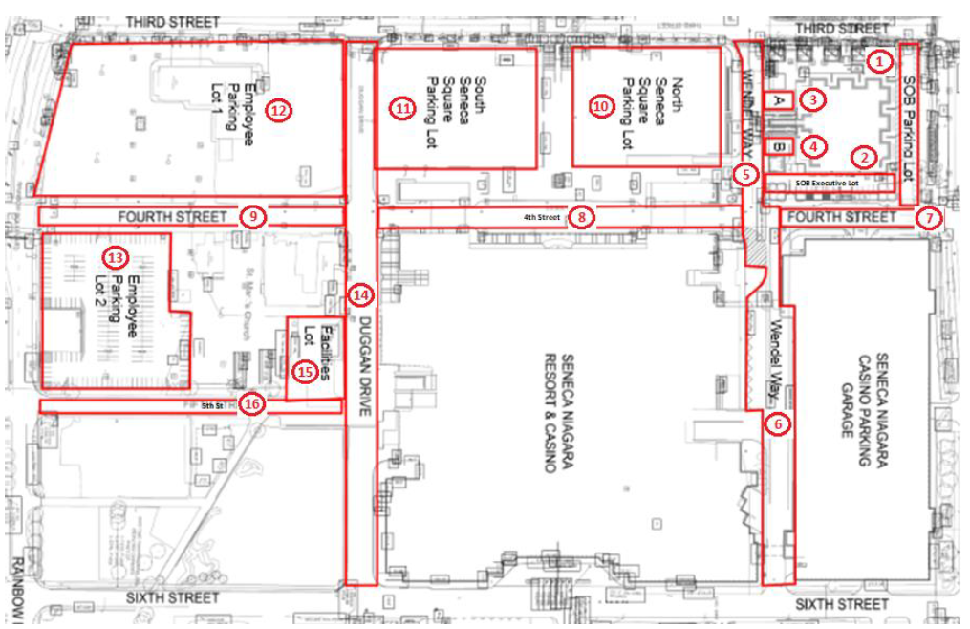
Niagara Asphalt Repair Property Map and Key
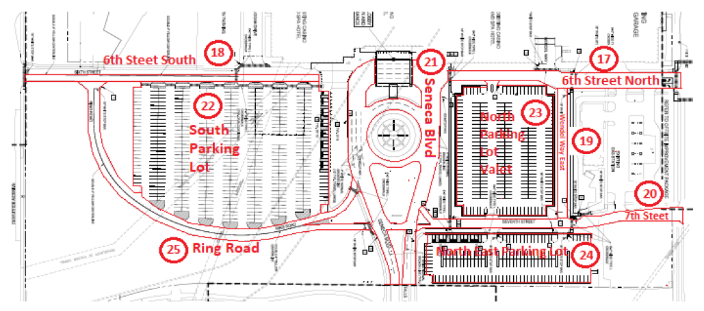
Niagara Asphalt Repair Property Map and Key
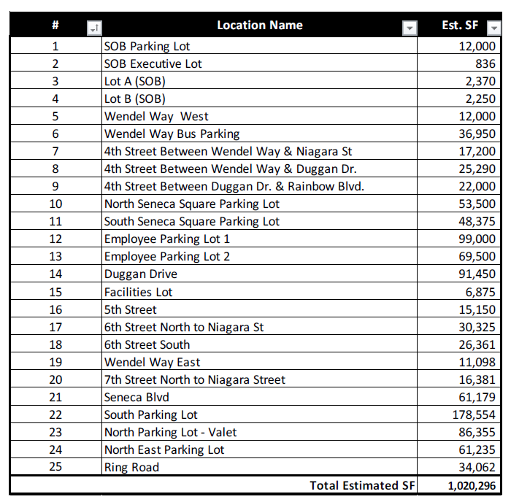
Niagara Asphalt Repair Property Map and Key

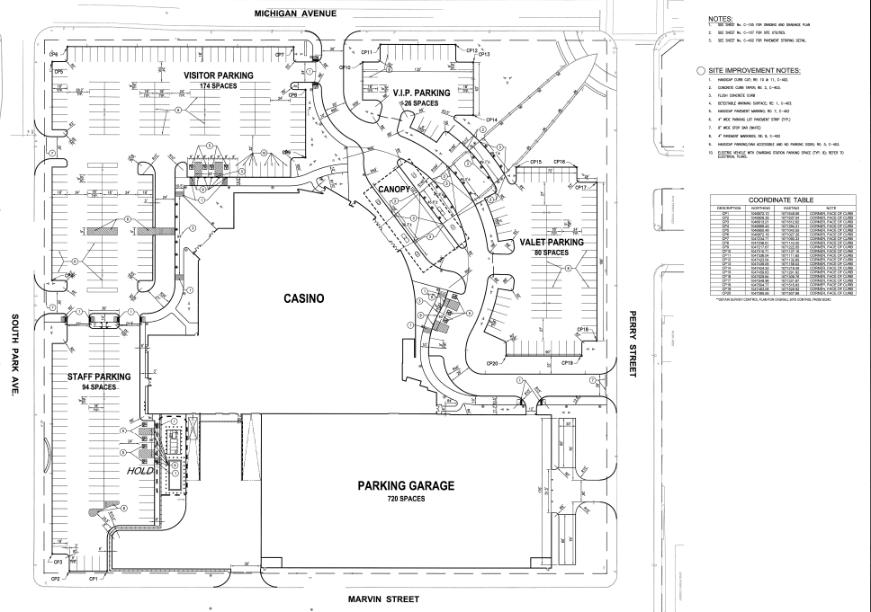
Buffalo Asphalt Repair Property Map
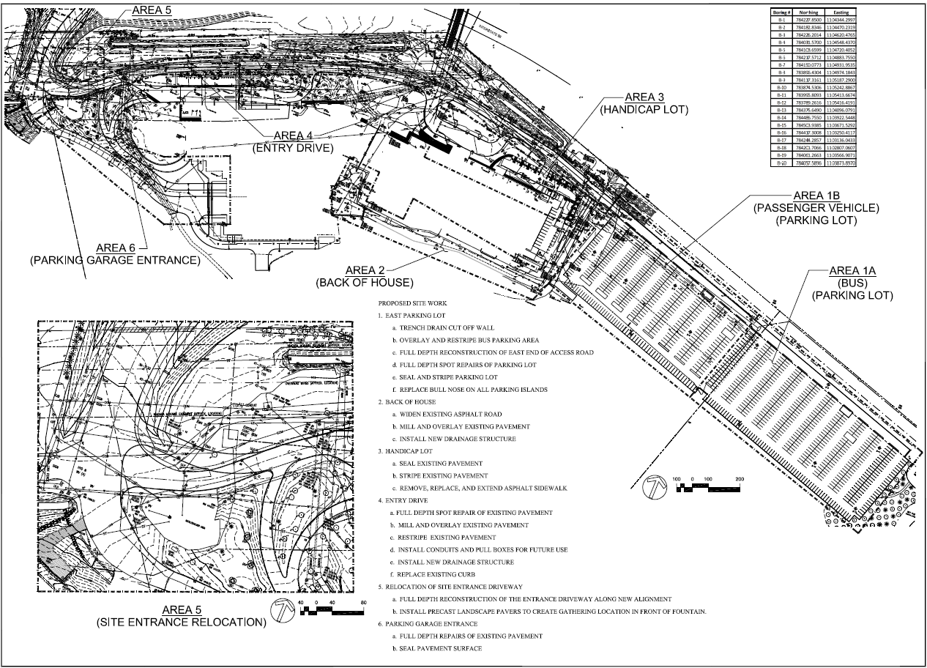
Allegany Asphalt Repair Property Map

