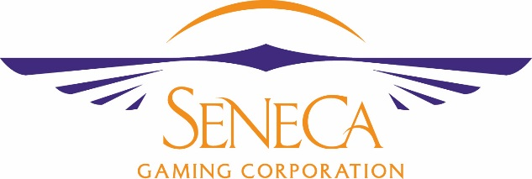

SENECA GAMING CORPORATION

April 9, 2021

Request for Quotation: RFQ #SGC-0030-21MC Whole Frozen Turkeys for SGC Employee Giveaway.

I. RFQ Overview
This is a Request for Quotation (RFQ) on behalf of the Seneca Gaming Corporation (SGC). It is imperative that you read and respond if you are interested in providing a proposal.

Any questions can be submitted via e-mail to Matthew Crvelin at mcrvelin@senecacasinos.com

The Seneca Gaming Corporation is seeking a distributor to supply 10-12LB whole frozen turkeys for an employee giveaway in November 2021. The Seneca Niagara Resort & Casino (SNRC) and Seneca Allegany Resort & Casino (SARC) would require a refrigerated trailer remain on property for the entirety of the giveaway.

Your proposal is due via e-mail to mcrvelin@senecacasinos.com by Wednesday, April 21, 2021, 5PM ET.

II. Seneca Gaming Requirements Overview
Go to WWW.SENECAGAMINGCORPORATION.COM to review SGC Business Standards for PO Terms and Conditions.

III. Specifications
The enclosed details related to the goods and/or services in this RFQ are based upon the operating department’s requirements.

SGC is looking to source 10/12 lb. whole frozen turkeys for delivery in November 2021 and require the specifications listed below.
- Vendor must be able to source and store turkeys until required date for delivery, which is scheduled for Wednesday, November 17, 2021.
- SNRC and SARC turkeys must be delivered in a refrigerated trailer, which are to remain on property for the entirety of the giveaway, and can be picked up on Saturday, November 20, 2021. *Delivery and pick up dates are subject to change.
- Please supply pricing for the day/week beginning 04/19/2021.

Turkey Counts:
SNRC – 1100 each
SBCC – 500 each
SARC – 700 each
TOTAL – 2300 each

IV. Proposal Format.
Please provide pricing on you company quotation form or letterhead.
Include pack size and price per pound with your bid.
List any additional discount/incentives if available.

SGC’s Standard Payment Terms are NET 30 days after delivery.

Matthew Crvelin
Food and Beverage Buyer
310 Fourth Street Niagara Falls, NY 14303
P: (716) 501-2190

